**WOA03393 – Electrovaya T.E.S.S**

**System Process Narrative**

Revision Date Revision # Description Issue Date

|  |  |  |  |
| --- | --- | --- | --- |
| 10th June 2016 | 1 | Draft | CONFIDENTIAL ECO-H |
| 13 January 2017 | 2 | Updated as Per PRD v4 | 170119 |
|  |  |  |  |
|  |  |  |  |
|  |  |  |  |
|  |  |  |  |
|  |  |  |  |

Authors:

David Forde

Herman Capadisli

**ACRONYMS AND DEFINITIONS**

1. **INTRODUCTION**
   1. **ELECTRICAL SYSTEM OVERVIEW**
   2. **MECHANICAL SYSTEM OVERVIEW**
2. **HARDWARE**
   1. **FIRE SUPPRESSION SYSTEM**
   2. **HVAC**
   3. **DELUGE**
   4. **PLC CONTROL PANEL**
   5. **ELECTRICAL INTERFACE**
3. **SECURITY**
4. **MANUAL CHARGING**
5. **SAFETY**
6. **SCADA SCREENS**
7. **MODES OF OPERATION**
8. **COMMUNICATION**
9. **OPERATOR PARAMETERS AND SET-POINTS**
10. **WARNINGS, ALARMS & FAULTS**

**APPENDICES**

**ACRONYMS**

|  |  |
| --- | --- |
| AC | ALTERNATING CURRENT |
| AI | ANALOGUE INPUT |
| AO | ANALOGUE OUTPUT |
| BB | BATTERY BANK |
| BMM | BATTERY MANAGEMENT MODULE |
| DI | DIGITAL INPUT |
| DO | DIGITAL OUTPUT |
| DC | DIRECT CURRENT |
| DOD | DEPTH OF DISCHARGE |
| ESSU | ENERGY STORAGE SYSTEM UNIT |
| FSS | FIRE SUPPRESSION SYSTEM |
| HMI | HUMAN MACHINE INTERFACE |
| HVAC | HEATING, VENTILATION, AIR CONDITIONING |
| IECS | INTERNAL ENVIRONMENTAL CONTROL SYSTEM |
| MBMM | MASTER BATTERY MANAGEMENT MODULE |
| MCB | MODULAR / MAIN CIRCUIT BREAKER |
| MW / KW | MEGAWATT / KILOWATT |
| PCS | POWER CONTROL SYSTEM |
| PLC | PROGRAMMABLE LOGIC CONTROLLER |
| ROR | RATE OF RISE |
| SCADA | SUPERVISORY CONTROL AND DATA ACQUISITION |
| SOC | STATE OF CHARGE |
| SOH | STATE OF HEALTH |
| SP | SET-POINT – OPERATOR ADJUSTABLE |
| UPS | UNINTERRUPTIBLE POWER SUPPLY |
| VFD | VARIABLE FREQUENCY DRIVE |
|  |  |
|  |  |
|  |  |
|  |  |
|  |  |
|  |  |
|  |  |
|  |  |
|  |  |
|  |  |
|  |  |
|  |  |

**DEFINITIONS**

|  |  |
| --- | --- |
| Battery Cell | Single/Elementary (Li) Battery cell. Vcell for Li type cells is xx(min) yy(nom)-zz(max) VDC. |
| Battery Module | Grouping of battery cells. Each battery module used System has xx battery cells connected in series together with cell monitoring and balancing electronics. |
| String | Grouping of Battery Modules to achieve desired Battery System voltage, Battery System Strings are connected in parallel to increase total Battery System capacity. |
| Rack (a.k.a.) Cabinet | The rack represents set of battery modules housed in a physical rack assembly, together with Control box and cables. |
| Container | TESS System enclosure that houses the entire Energy Storage system. |
| Compartment | Part of TESS System enclosure/container housing specific equipment.  Examples:   1. Battery Compartment 2. Electrical Compartment |
| Balancing | Cells Voltage Balancing- Process of maximizing the capacity of a battery pack with multiple connected in series cells by equalizing cells Voltage (SOC). Cell Voltage balancing between cells inside of Battery Module is active at all times. |
| Power Conversion System (PCS) | Consist of Bidirectional AC/DC Inverter, Main System (PLC) Controller, user and communication interface and isolation transformer. |
| Tare losses | Loss caused by the controller. One minus tare loss, expressed as a percentage, is equal to the controller efficiency. |
| FM-200 | Chemical Clean Fire  Suppression Agent (Fire Suppression System) |
| Deluge | Water Sprinkler Fire Suppression System. |
| Rack specification e.g.  24”46U | Standard Rack specification;  Where: 24” (609.6mm)-Width of the rack; U-Height Space Unit = 1.75” (44.45mm) of Height ;  xx Height total; yy Depth total. |

**1.0 INTRODUCTION**

Electrovaya’s Transportable Energy Storage System (TESS) is designed to provide and/or supplement Grid AC Power. Energy is stored in the Battery system then converted to 3Ph Grid voltage when needed as either 208VAC or 460VAC. The TESS system is transportable to the site of and when not in use is to be kept charged at all times. Charging is possible from the Grid or from input only Auxiliary Power source (e.g. Diesel Generator set) via an internal dedicated battery charger.

**1.1 ELECTRICAL SYSTEM OVERVIEW**

|  |  |
| --- | --- |
| Auxiliary Power input | 3Ph , 208 VAC Ph-Ph,120VAC Ph-N (+N and GND), +-10%; 35kVA; 100A |
| Frequency | 60 Hz +-0.5Hz |
| Generated Harmonics | <3% THD at rated Power |
| PCS (Inverter) Nominal Rated Power | 500 kVA |
| Battery System Rated Capacity @500kW Output power | 800 kWh |
| Number of Racks in the Battery System | 10 |
| Number of Strings per Rack | 1 |

**1.2 MECHANICAL SYSTEM OVERVIEW**

|  |  |
| --- | --- |
| Container Dimensions | 40’L x 8W’ x 12½’H / 12.2L x 2.44W x 3.82H. |
| Total Gross Weight | <62,000 lb. / 27,215 kg – Including Trailer. |
| Shock and vibration damping | The fully loaded container and trailer shall limit maximum vibration input to interior to 0.3mm (2-9Hz) and 1m/s2 (9-200Hz) (test per IEC 60068-2-6). The fully loaded container and trailer shall limit maximum shock input to interior to 40m/s2 of duration 22ms (test per IEC 60068-2-27). |
| Structural requirements | Snow or Wind Load: Per CFR 24 Subtitle B Zone 1 (max 15 lbs per sq ft) |
| Deployment Time | 3 hours to disconnect/pack, 3 hours to unpack/hookup/start. |

**2.0 HARDWARE**

**2.1 FIRE SUPPRESSION SYSTEM**

**FM200 AGENT – PRESSURIZED**

The FM-200 Fire Suppression System is an engineered system utilizing a fixed nozzle agent distribution network. The system is designed and installed in accordance with the National Fire Protection Association (NFPA) Standard 2001, “Clean Agent Fire Extinguishing Systems.”

**COMBINED HEAT & SMOKE DETECTORS**

When smoke is detected or the temperature climbs above the fixed temperature rating of 135°F the detector sends a signal to the PLC Control Panel and the FSS

Control Panel.

**2.2 HVAC**

**SYSTEM DESCRIPTION**

Consisting of TWO independent heating & cooling systems (LH & RH) rated at 208VAC, 5-TON each with 5KW resistive heating, wall mounted single Zone units with built-in control. These HVAC units will communicate via Ethernet to the TESS PLC Control Panel for alarming, operation and remote control purposes. The units will maintain an ambient temperature as determined by the operator set-point parameter and within a HI and LO temperature range. If the ambient temperature goes outside of this range the redundant HVAC unit will automatically operate to compensate.

Both HVAC systems are to be operated independently and automatically ‘switch’ control from LH to RH every 8 hours of operation to ensure equal usage.

**2.3 DELUGE**

INCOMPLETE

**2.4 PLC CONTROL PANEL**

The PLC Control Panel will consist of an Allen Bradley PLC CompactLogix as defined below:

|  |  |  |  |  |  |
| --- | --- | --- | --- | --- | --- |
| L32E CONTROLLER | POWER SUPPLY | DIGITAL INPUT CARD | DIGITAL OUTPUT CARD | ANALOGUE INPUT CARD | ANALOGUE OUTPUT CARD |
| **1769-L32E** | **1769-PA4** | **1769-IQ32** | **1769 OB32** | **1769-IF8** | **1769-OF8C** |

**Digital Input Card 1769-IQ32**

|  |  |  |  |
| --- | --- | --- | --- |
| **DI** | **REFERENCE** | **Description** | **DI** |
| 1 | MODE OF OPERATION - AUTO | Selector switch to put TESS into AUTO | 1 |
| 2 | MODE OF OPERATION - MANUAL | Selector switch to put TESS into MANUAL | 1 |
| 3 | FSS HEALTH | Input from FSS for healthy/fault signal | 1 |
| 4 | BMM HEALTH | Input from BMM for healthy/fault signal | 1 |
| 5 | HVAC 1 | Input from HVAC 1 ensuring healthy/fault signal | 1 |
| 6 | HVAC 2 | Input from HVAC 2 ensuring healthy/fault signal | 1 |
| 7 | ELECTRICAL ROOM DOOR SWITCH | Electrical Room Door OPEN | 1 |
| 8 | ALARM RESET/MUTE | Resets alarms/mutes alarms for "x" minutes | 1 |
| 9 | PRIMARY TRANSFORMER TEMP | High temp | 1 |
| 10 | PRIMARY TRANSFORMER TEMP | Over temp | 1 |
| 11 | BATTERY ROOM DOOR OPEN | Battery Room Door OPEN | 1 |
| 12 | 460 VAC DISCONNECT CLOSED | Disconnect is closed | 1 |
| 13 | 208 VAC DISCONNECT CLOSED | Disconnect is closed | 1 |
| 14 | FLOOD SENSOR | Battery Room Flood Alarm | 1 |
| 15 |  |  |  |
| 16 | HVAC on/off status |  |  |
| 17 |  |  |  |
| 18 |  |  |  |
| 19 |  |  |  |
| 20 |  |  |  |
| 21 |  |  |  |
| 22 |  |  |  |
| 23 |  |  |  |
| 24 |  |  |  |
| 25 |  |  |  |
| 26 |  |  |  |
| 27 |  |  |  |
| 28 |  |  |  |
| 29 |  |  |  |
| 30 |  |  |  |
| 31 |  |  |  |
| 32 |  |  |  |
|  |  |  | 13 |

**Digital Output Card 1769-OB32**

|  |  |  |  |  |  |  |
| --- | --- | --- | --- | --- | --- | --- |
| **DO** | **REFERENCE** | | **Description** | | | **DO** |
| 1 | FIELD STATUS OK LAMP | | Field status OK Light | | | 1 |
| 2 | SYSTEM AC LAMP | | Light indicating healthy AC power | | | 1 |
| 3 | SYSTEM DC LAMP | | Light indicating healthy DC power | | | 1 |
| 4 | TO BMS - FSS HEALTHY | | Signal for BMS to ensure FSS is healthy | | | 1 |
| 5 | HORN - INTERNAL | | Horn on front of PLC panel | | | 1 |
| 6 | PULSED RESET COMMAND TO PCS | | Reset command to PCS | | | 1 |
| 7 | PULSED START COMMAND TO PCS | | Start command to PCS | | | 1 |
| 8 | PULSED STOP COMMAND TO PCS | | Stop command to PCS | | | 1 |
| 9 | PLC FAULT/ALARM ADVISORY | | PLC fault | | | 1 |
| 10 | SSR1 OK FROM PLC TO PC | | SSR1 ok | | | 1 |
| 11 | TESS HEALTH OK FROM PLC TO PCS | | TESS health ok | | | 1 |
| 12 | ENABLE 208 VAC SHUNT TRIP | | 208 Shunt enable | | | 1 |
| 13 | ENABLE 480 VAC SHUNT TRIP | | 480 Shunt enable | | | 1 |
| 14 | ETHER DISSCONNECT IS CLOSED | | Ether disconnect is closed | | | 1 |
| 15 | SSR2 OK FROM PLC TO PCS | | SSR2 ok | | | 1 |
| 16 | RED LAMP (ON TOWER) - FUTURE | | Not ready/fault on outside of TESS | | | 1 |
| 17 | AMBER LAMP (ON TOWER) - FUTURE | | TESS is off (or minor fault) but ready to start | | | 1 |
| 18 | GREEN LAMP (ON TOWER) - FUTURE | | TESS is running | | | 1 |
| 19 | HORN - EXTERNAL | | Exterior horn above Control Room man door | | | 1 |
| 20 |  | |  | | |  |
| 21 |  | |  | | |  |
| 22 |  | |  | | |  |
| 23 |  | |  | | |  |
| 24 |  | |  | | |  |
| 25 |  | |  | | |  |
| 26 |  | |  | | |  |
| 27 |  | |  | | |  |
| 28 |  | |  | | |  |
| 29 |  | |  | | |  |
| 30 |  | |  | | |  |
| 31 |  | |  | | |  |
| 32 |  | |  | | |  |
|  |  | |  | | | 18 |
|  |  |  | |  |  |
|  |  |  | |  |  |

**Analog Input Card 1769-IF8**

|  |  |  |  |
| --- | --- | --- | --- |
| **AI** | **REFERENCE** | **Description** | **AI** |
| 1 | BATTERY ROOM TEMPERATURE | Temperature of battery compartment | 1 |
| 2 | ELECTRICAL ROOM TEMPERATURE | Temperature of electrical compartment | 1 |
| 3 | INVERTER FEEDBACK | Input from Inverter to indicate correct reference | 1 |
| 4 |  |  |  |
| 5 |  |  |  |
| 6 |  |  |  |
| 7 |  |  |  |
| 8 |  |  |  |
|  |  |  | 3 |

**Analog Output Card 1769-OF8C**

|  |  |  |  |
| --- | --- | --- | --- |
| **AO** | **REFERENCE** | **Description** | **AO** |
| 1 | INVERTER REFERENCE | Output to PCS for control | 1 |
| 2 |  |  |  |
| 3 |  |  |  |
| 4 |  |  |  |
| 5 |  |  |  |
| 6 |  |  |  |
| 7 |  |  |  |
| 8 |  |  |  |
|  |  |  | 1 |

Operational indicators and actuators are identified as follows:

* EMERGENCY STOP BUTTON – RED
* RESET / MUTE BUTTON – BLACK
* 3-POSITION SELECTOR SWITCH – BLACK
  + GRID-TIE
  + OFF
  + ISLAND
* 3-POSITION SELECTOR SWITCH – BLACK
  + 208VAC
  + OFF
  + 460VAC
* AUDIBLE PIEZO BUZZER
* AC POWER – WHITE
* PCS HEALTH – GREEN
* BATTERY MANAGER HEALTH – GREEN
* UPS HEALTH – GREEN
* SAFETY SYSTEM HEALTH – GREEN
* POWER INTERLOCK(S) HEALTH – GREEN

Operator system interface and control is via the 17” Industrial Color Touch Screen (HMI) with built-in PC operating the following software:

* Windows 7 Ultimate Pro with SP1
* Microsoft Office 2010
* Internet Explorer 11.0
* Adobe Reader
* Factory talk SE ver #9 standalone with up to 15 screens  
  RS Linx and License

17” Industrial Color Touch Screen (HMI) Specifications

* 17 inch color TFT
* 1280 x 1024 resolution SXGA
* Analog Resistive Touch Screen
* Intel® Core™2 Duo
* 4GB DDR RAM
* 320 GB Hard Drive with Anti -shock
* Windows 7 PRO with Service Pack 1
* 4 USB Ports
* Dual 10/100/1000 Mbps Ethernet
* 1 Serial Port RS422/RS485 selectable
* 4 Serial Ports RS232
* 1 x SATA II
* Compact Flash Slot Type II
* 220 Watt ATX power supply
* Die Cast Aluminum NEMA 4/IP65 front bezel

A fold-down shelf will be installed on the exterior of the PLC Control Panel and house an electrical receptacle and Ethernet port for programming and monitoring purposes.

**2.5 ELECTRICAL INTERFACE**

The TESS System offers TWO Grid connections at 3 Phase 208VAC Ph-Ph and 460 VAC Ph-Ph Voltages although these connections remain mechanically and electrically independent of each other. Selection of the preferred output voltage is performed by the system operator via a two position selector switch on the front of the PLC Control Panel and is a required manual operation. The system is capable of outputting and inputting full power at both Grid voltages independently via the connectors at each interface panel located outside the TESS unit. The Electrical connectors are of the type Leviton 16S31 (CamLock, 16 series) female receptacles and are color coded according to NEC (National Electrical Code-USA).

The TESS System incorporates fusible load rated Safety Disconnect(s) for both 208VAC Ph-Ph and 460VAC Ph-Ph Vac.

**3.0 SECURITY**

Operator control and system operations are protected by a 3-tier log-in security access system within the HMI identified as OPERATOR, MANAGER and ENGINEER. Each level of access will offer increased levels of operator usability and parameter set-points. These are identified in section **10.1 SETPOINTS.**

Each security level is accessible with a unique ‘per-person’ PIN number and in MANAGER and ENGINEER access there is a default time-out of 10 minutes before the system HMI returns to the home screen. If continued work is required at this level of access the operator must re log-in.

**4.0 MANUAL CHARGING**

Manual Charging is only possible with Mode of Operation selector switch in the OFF position. When ready the operator can select the appropriate Manual Charge screen on the HMI and begin operating the unit as a manual stand-alone system. If the selector switch is moved out of the OFF position the manual charge will cease and PCS system will perform a fast shut down and enter into a fault mode.

**5.0 SAFETY**

Safety integrity level (SIL) is defined as a relative level of risk-reduction provided by a safety function, or to specify a target level of risk reduction and there are four discrete integrity levels associated with SIL. The higher the SIL level, the lower the probability of failure on demand for the safety system and the better the system performance. The SIL level applies to the TESS system and individual products or components do not have SIL ratings.

The TESS System is designed to a level of SIL-1.

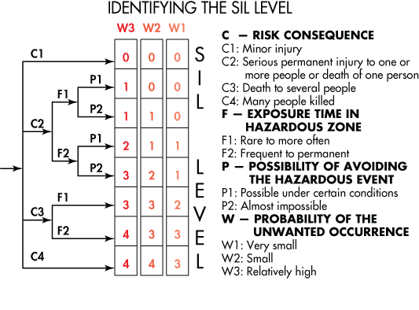

There are TWO emergency stop buttons, one is located outside the TESS unit next to the man door and one is internally mounted on the front of the PLC Control Panel. Operation of either of these buttons will cause the following effects and the sequence of these operations is not defined due to numerous and unknown variables:

* Emergency Safety Relay (internal to PLC Control Panel) will disengage
* Grid-Tie disconnect switch for 208VAC (if engaged) will disengage
* Grid-Tie disconnect switch for 460VAC (if engaged) will disengage
* PCS output capability will cease (if discharging)
* PCS input capability will cease (if charging)
* HVAC power is removed
* Auxiliary power (lighting, receptacles, etc) is removed

In an emergency event the following hardware will remain active and under UPS power for the duration of the UPS capability (typically 1 hour). After this time the hardware will cease to operate:

* UPS
* PLC Controller
* HMI
* WI-FI / Radio
* Fire Alarm Control Panel (with built-in battery back-up)

**6.0 SCADA SCREENS**

The system HMI allows for up to 15 operator screens viewable from the HMI identified below and titled as:

1. Home Screen
2. Operation Screen
3. Alarms & Reports
4. Set-Points 1 of 2
5. Set-Points 2 of 2
6. Battery System
7. Manual Charging
8. Safety & Interlocks
9. Battery Detail
10. “Alpha-Numeric Keyboard”
11. “Number Keypad”
12. “Are You Sure?”
13. “Request Not Authorized”
14. Spare
15. Spare
16. Spare
    1. **HOME SCREEN**

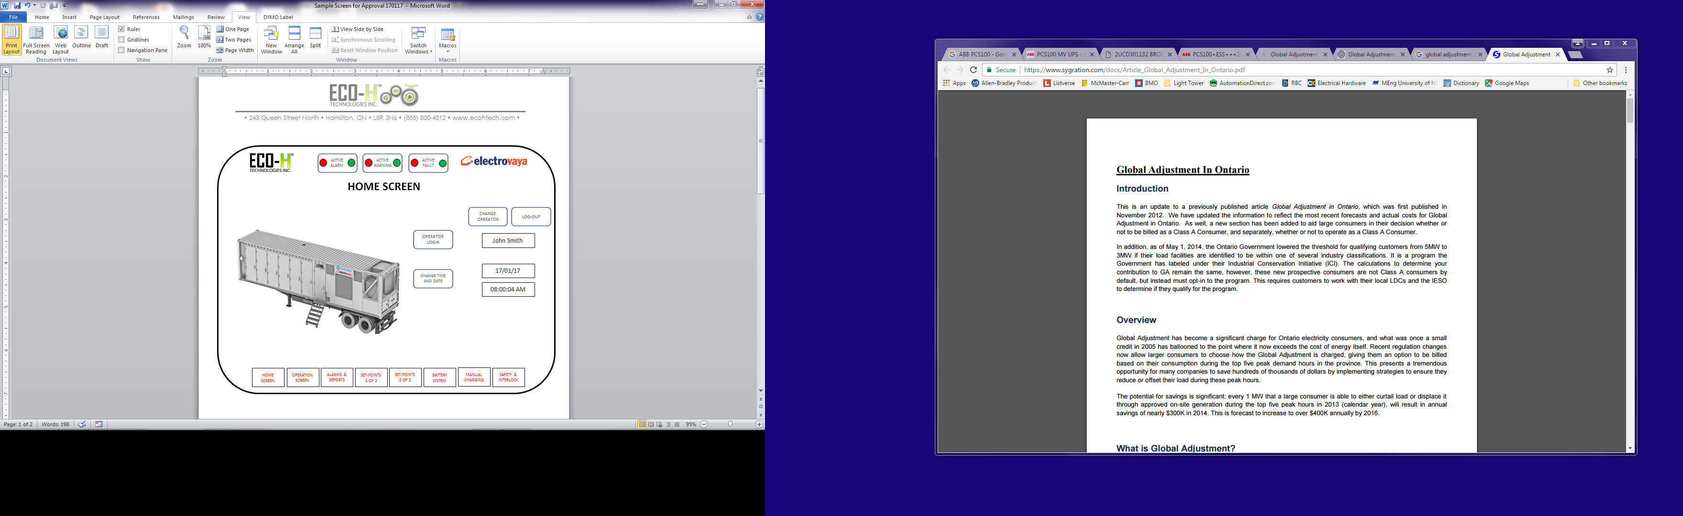

* 1. **Operation Screen**

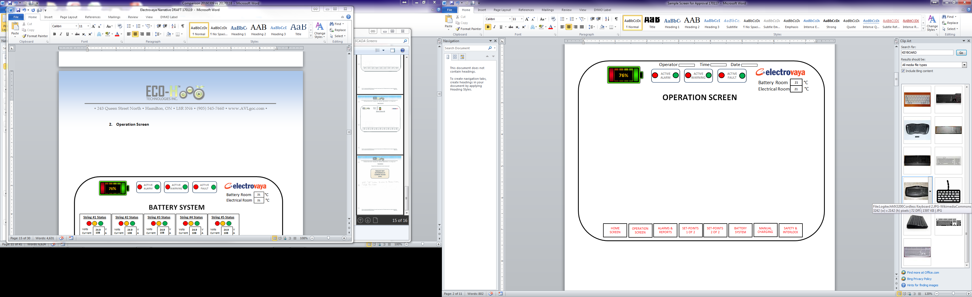

* 1. **Alarms & Reports**

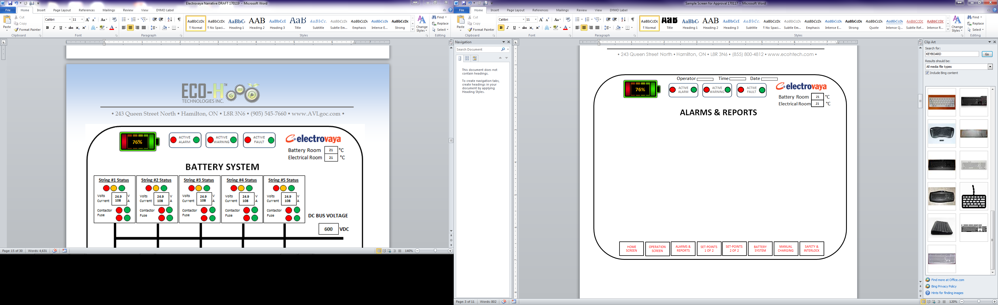

* 1. **Set-Points 1 of 2**

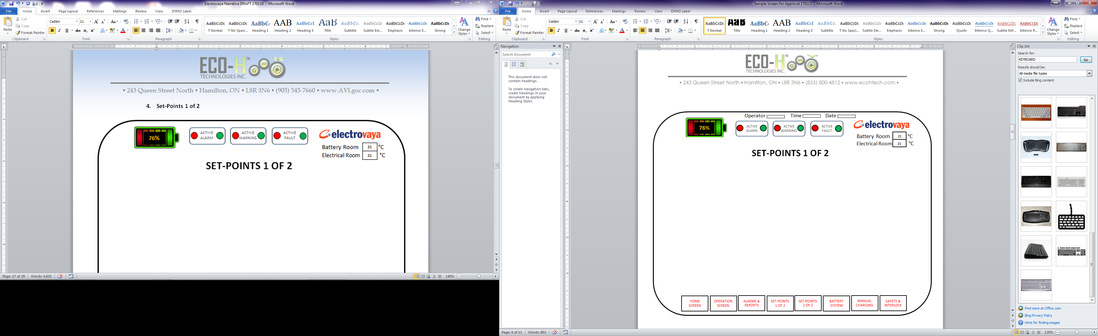

* 1. **Set-Points 2 of 2**

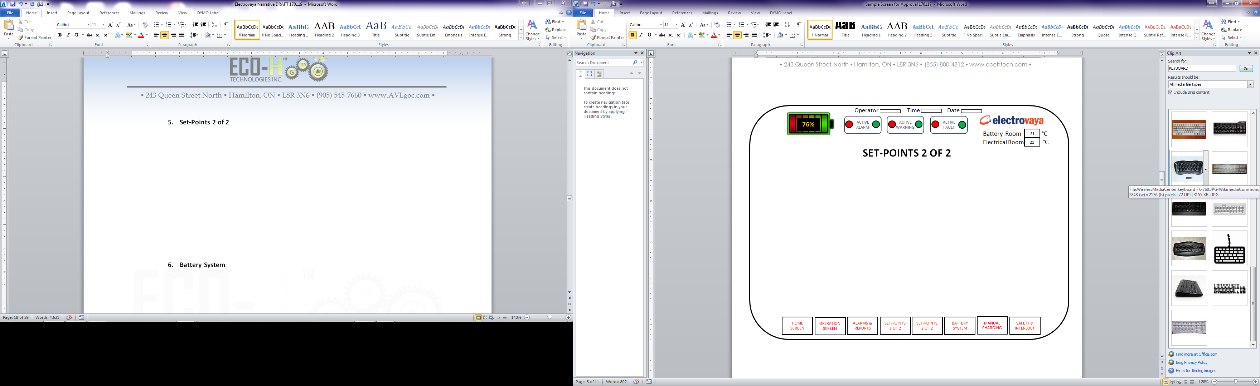

* 1. **Battery System**

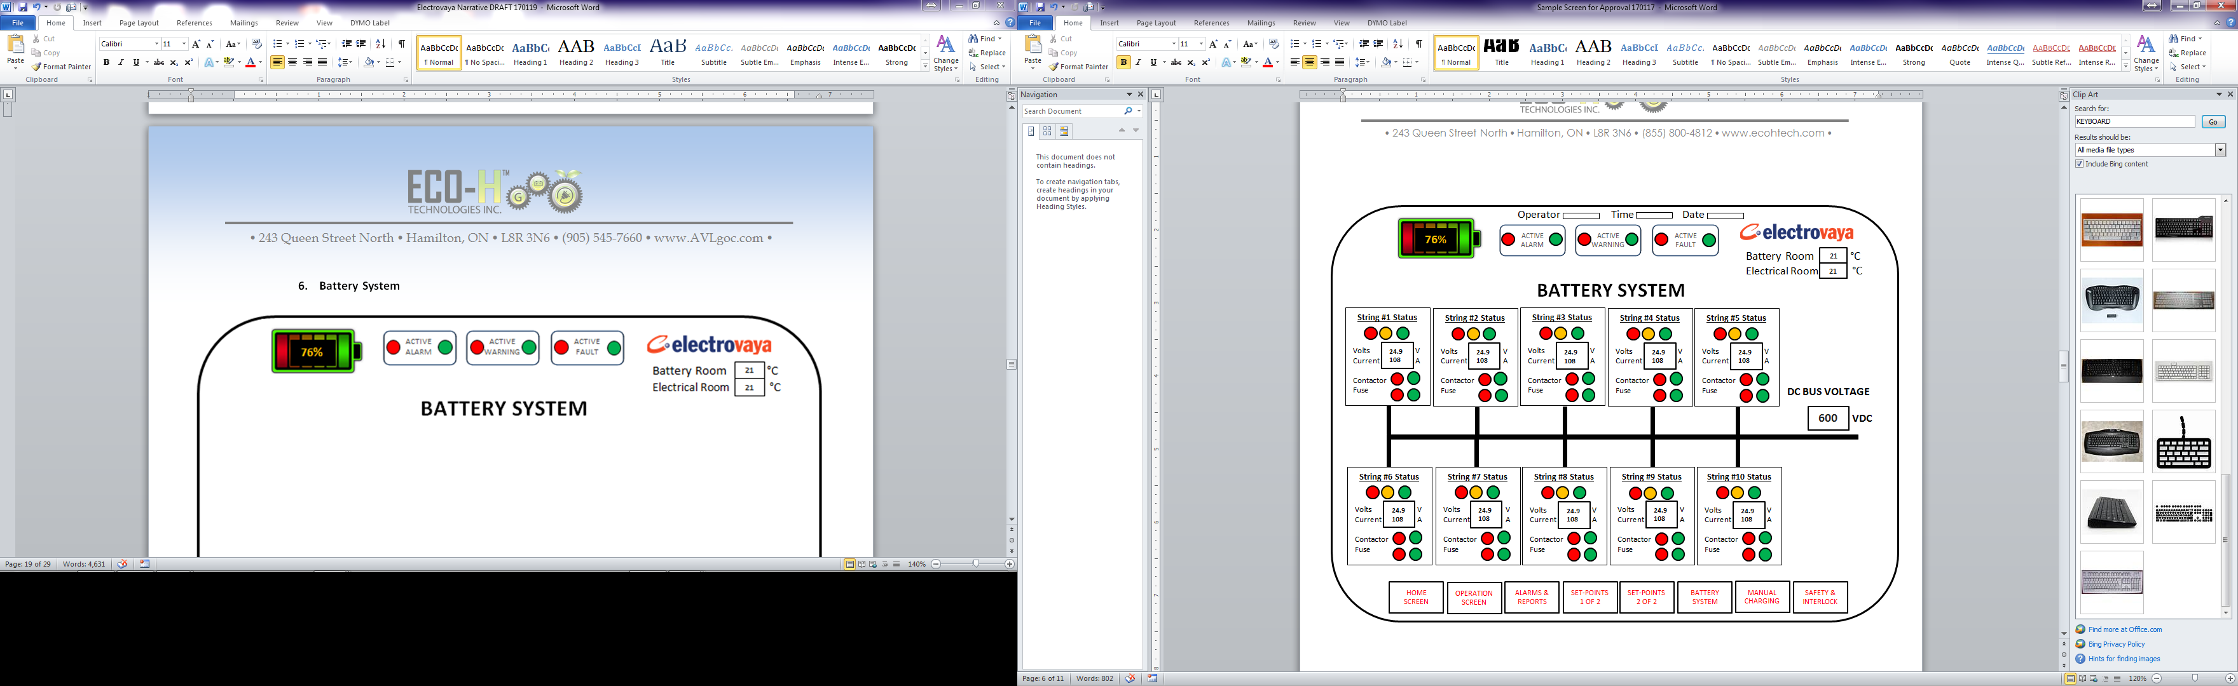

* 1. **Manual Charging**

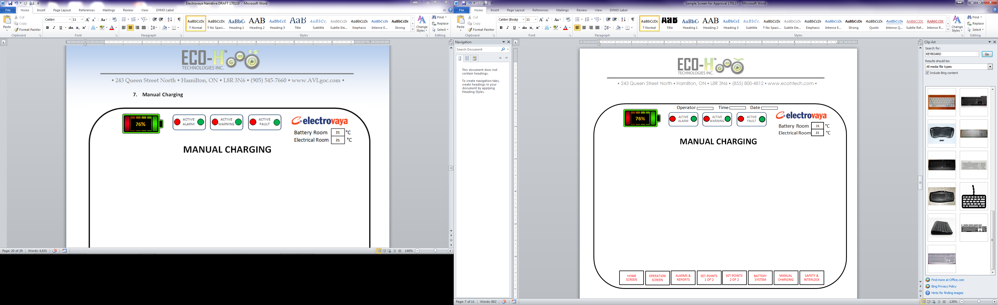

* 1. **Safety & Interlocks**

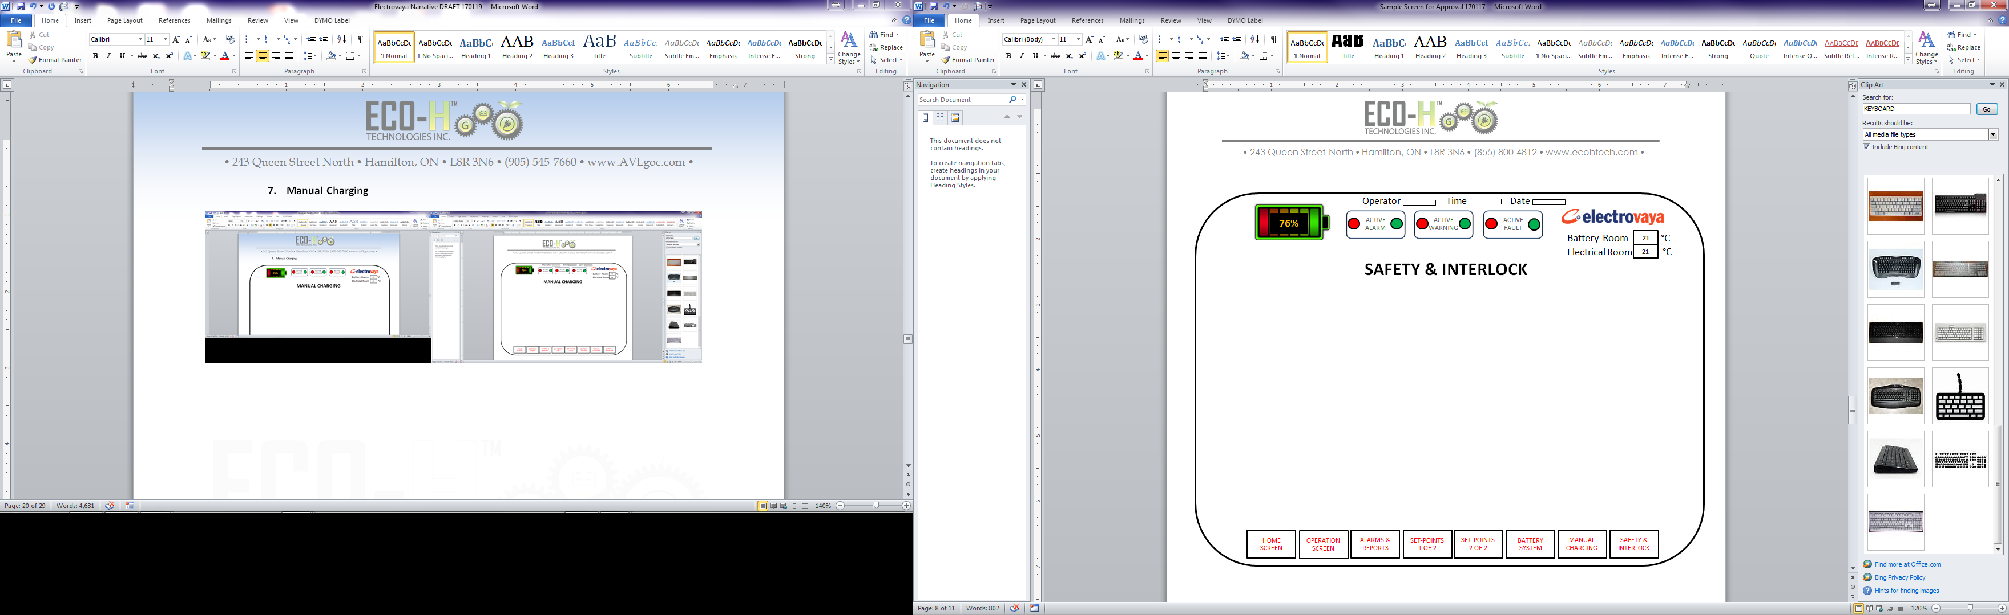

* 1. **Battery Detail**

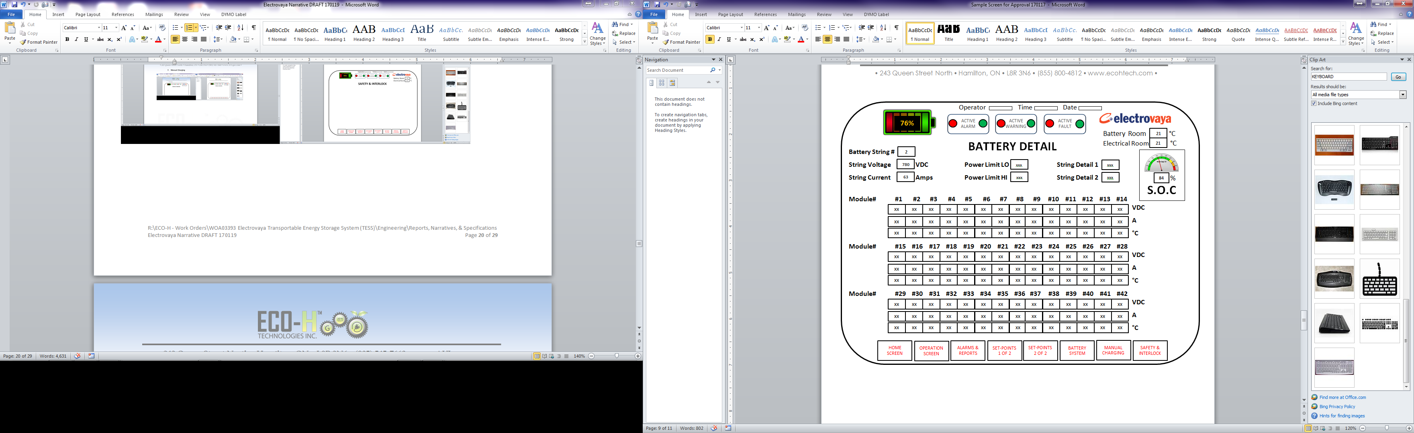

* 1. **Alpha-Numeric Keyboard**

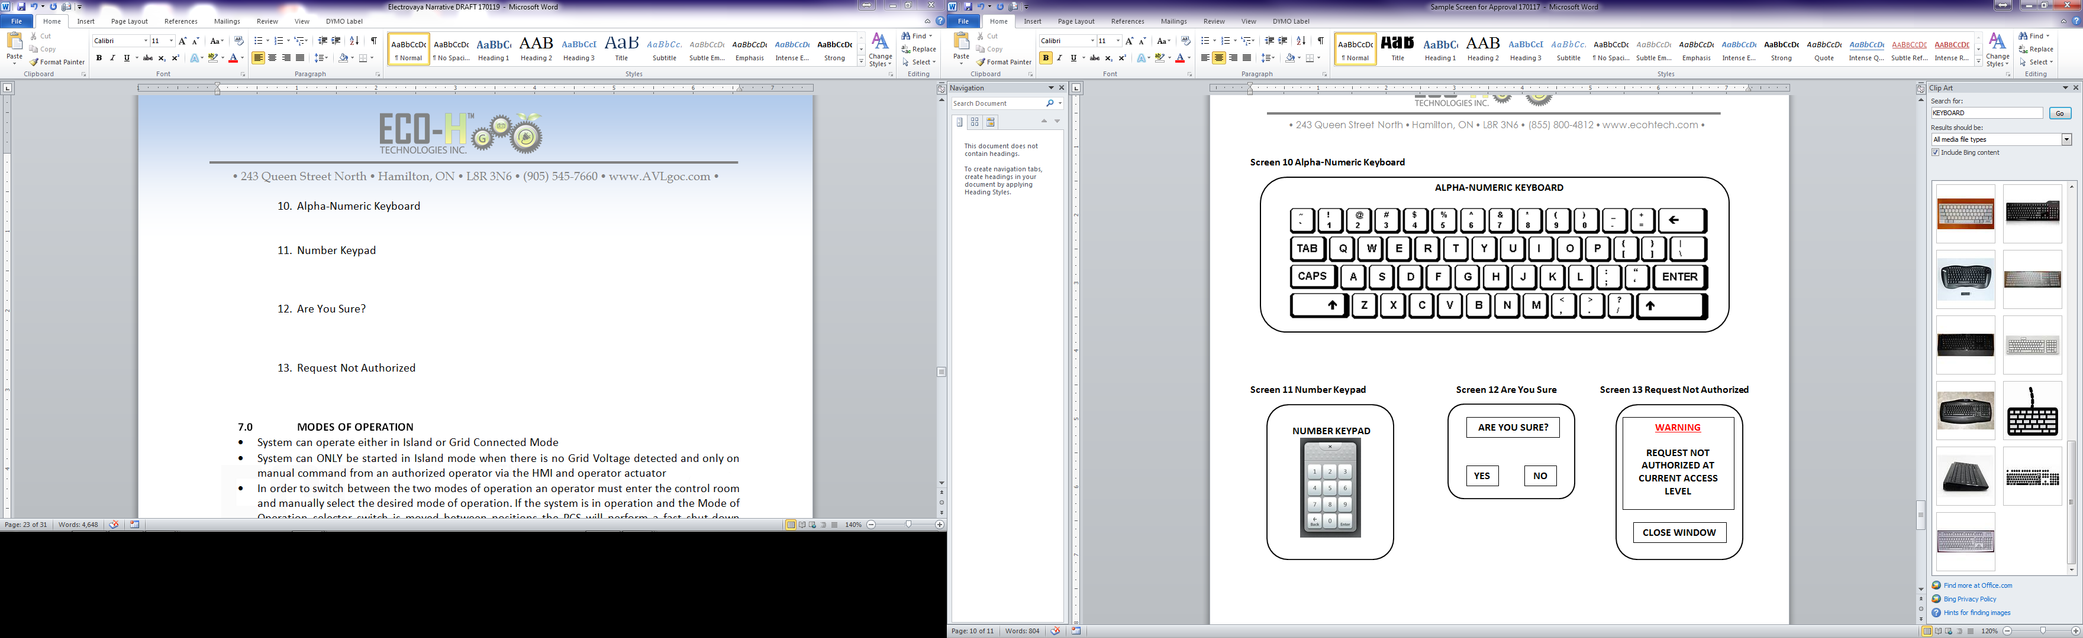

* 1. **Number Keypad**



* 1. **Are You Sure?**



* 1. **Request Not Authorized**



**7.0 MODES OF OPERATION**

* System can operate either in Island or Grid Connected Mode
* System can ONLY be started in Island mode when there is no Grid Voltage detected and only on manual command from an authorized operator via the HMI and operator actuator
* In order to switch between the two modes of operation an operator must enter the control room and manually select the desired mode of operation. If the system is in operation and the Mode of Operation selector switch is moved between positions the PCS will perform a fast shut-down operation and enter a fault mode. All input or output power will cease however the TESS system will remain electrically ‘live’ and not enter the Emergency Stop Procedure
* The system will NOT perform an immediate transfer between modes of operation automatically, manually or via the HMI
* On the HMI Operation Screen will be the operator ‘START’ and ‘STOP’ controls. Once activated by an authorized (logged-in) person a pop-up screen will display asking “Are You Sure?” If “OK” is selected the system will become active conditional to the alarming table in section 10.
* In Island mode the system and with the battery system not indicating fault condition(s) ‘Black Start’ operations can commence. This is achieved by an operator selecting the appropriate manual selector switch settings for Mode of Operation and Output Voltage then entering the HMI appropriate screen and engaging the system. The internal TESS UPS enables this to occur until the TESS output is operational at which time power is used from the battery system to power the unit and recharge the dedicated UPS
* An External power source can be connected in the event that the TESS internal UPS is discharged, immediate operation may not be possible if the internal ambient temperature is outside of the operating range of the TESS system. When the internal temperature is reached the system will be operation in both mode of operation and will automatically initiate a recharge of the internal UPS
* During operation in either mode all internal memories and data points will be ‘readable’ from an external SCADA, Historian or other connected device either through direct Ethernet connection or via Wi-Fi or Telecommunication access
* There is no facility to perform data storage within the HMI or PLC
* The built-in HMI industrial PC has limited memory capability (320GB hard drive – Section 2.4 PLC CONTROL PANEL) and can be used as a temporary storage medium

**8.0 COMMUNICATION**

With reference to Appendix A the communication interface is via the plugboard Ethernet connection ports #1 and #2 and both connectors have weatherproof protection in the form of screw down protective caps.

Hardwired from the 16-port Ethernet Router is a single unit mounted external to the TESS container which houses two communication systems, Wi-Fi and Cellular radio. Using either medium or Ethernet port remote access can be achieved

**9.0 OPERATOR PARAMETERS AND SET-POINTS**

|  |  |  |  |
| --- | --- | --- | --- |
| **PARAMETER** | **OPERATOR ACCESS LEVEL** | | |
| **OPERATOR** | **MANAGER** | **ENGINEER** |
| SOC HI-HI LIMIT - % | **N** | **Y** | **Y** |
| SOC HI LIMIT - % | **N** | **Y** | **Y** |
| SOC LO LIMIT - % | **N** | **Y** | **Y** |
| SOC LO-LO LIMIT - % | **N** | **Y** | **Y** |
| MAX RATE OF CHARGE - CAPACITY % | **N** | **N** | **Y** |
| MAX OUTPUT POWER - KW | **N** | **N** | **Y** |
| MIN OUTPUT POWER - BASE LOADING - KW | **N** | **N** | **Y** |
| OUTPUT START DELAY - SEC | **N** | **N** | **Y** |
| MAX OUTPUT RATE OF CHANGE - KW/SEC | **N** | **N** | **Y** |
| ENABLE MANUAL CHARGING | **N** | **Y** | **Y** |
| BATTERY ROOM TEMP HI LIMIT | **N** | **N** | **Y** |
| BATTERY ROOM TEMP LO LIMIT | **N** | **N** | **Y** |
| ELECTRICAL ROOM TEMP HI LIMIT | **N** | **N** | **Y** |
| ELECTRICAL ROOM TEMP LO LIMIT | **N** | **N** | **Y** |

**10.0 WARNINGS, ALARMS & FAULTS**

|  |  |  |  |  |  |  |  |
| --- | --- | --- | --- | --- | --- | --- | --- |
| **Alarm #** | **Alarm String** | **Alarm Description** | **Local Monitor** | **Remote Monitor** | **Visual Alarm SCADA** | **Audio Alarm Control Panel** | **Full Shutdown** |
| **1** | SOC_String_1 | String SOC - HIGH | Y | Y | Y | Y | N |
| **2** | SOC_String_2 | String SOC - HIGH | Y | Y | Y | Y | N |
| **3** | SOC_String_3 | String SOC - HIGH | Y | Y | Y | Y | N |
| **4** | SOC_String_4 | String SOC - HIGH | Y | Y | Y | Y | N |
| **5** | SOC_String_5 | String SOC - HIGH | Y | Y | Y | Y | N |
| **6** | SOC_String_6 | String SOC - HIGH | Y | Y | Y | Y | N |
| **7** | SOC_String_7 | String SOC - HIGH | Y | Y | Y | Y | N |
| **8** | SOC_String_8 | String SOC - HIGH | Y | Y | Y | Y | N |
| **9** | SOC_String_9 | String SOC - HIGH | Y | Y | Y | Y | N |
| **10** | SOC_String_10 | String SOC - HIGH | Y | Y | Y | Y | N |
| **11** | SOC_String_1 | String SOC - LOW | Y | Y | Y | Y | N |
| **12** | SOC_String_2 | String SOC - LOW | Y | Y | Y | Y | N |
| **13** | SOC_String_3 | String SOC - LOW | Y | Y | Y | Y | N |
| **14** | SOC_String_4 | String SOC - LOW | Y | Y | Y | Y | N |
| **15** | SOC_String_5 | String SOC - LOW | Y | Y | Y | Y | N |
| **16** | SOC_String_6 | String SOC - LOW | Y | Y | Y | Y | N |
| **17** | SOC_String_7 | String SOC - LOW | Y | Y | Y | Y | N |
| **18** | SOC_String_8 | String SOC - LOW | Y | Y | Y | Y | N |
| **19** | SOC_String_9 | String SOC - LOW | Y | Y | Y | Y | N |
| **20** | SOC_String_10 | String SOC - LOW | Y | Y | Y | Y | N |
| **21** | Min_Cell_Voltage_String_1 | String minimum cell voltage - LOW | Y | Y | Y | N | N |
| **22** | Min_Cell_Voltage_String_2 | String minimum cell voltage - LOW | Y | Y | Y | N | N |
| **23** | Min_Cell_Voltage_String_3 | String minimum cell voltage - LOW | Y | Y | Y | N | N |
| **24** | Min_Cell_Voltage_String_4 | String minimum cell voltage - LOW | Y | Y | Y | N | N |
| **25** | Min_Cell_Voltage_String_5 | String minimum cell voltage - LOW | Y | Y | Y | N | N |
| **26** | Min_Cell_Voltage_String_6 | String minimum cell voltage - LOW | Y | Y | Y | N | N |
| **27** | Min_Cell_Voltage_String_7 | String minimum cell voltage - LOW | Y | Y | Y | N | N |
| **28** | Min_Cell_Voltage_String_8 | String minimum cell voltage - LOW | Y | Y | Y | N | N |
| **29** | Min_Cell_Voltage_String_9 | String minimum cell voltage - LOW | Y | Y | Y | N | N |
| **30** | Min_Cell_Voltage_String_10 | String minimum cell voltage - LOW | Y | Y | Y | N | N |
| **31** | Max_Cell_Voltage_String_1 | String maximum cell voltage - HIGH | Y | Y | Y | N | N |
| **32** | Max_Cell_Voltage_String_2 | String maximum cell voltage - HIGH | Y | Y | Y | N | N |
| **33** | Max_Cell_Voltage_String_3 | String maximum cell voltage - HIGH | Y | Y | Y | N | N |
| **34** | Max_Cell_Voltage_String_4 | String maximum cell voltage - HIGH | Y | Y | Y | N | N |
| **35** | Max_Cell_Voltage_String_5 | String maximum cell voltage - HIGH | Y | Y | Y | N | N |
| **36** | Max_Cell_Voltage_String_6 | String maximum cell voltage - HIGH | Y | Y | Y | N | N |
| **37** | Max_Cell_Voltage_String_7 | String maximum cell voltage - HIGH | Y | Y | Y | N | N |
| **38** | Max_Cell_Voltage_String_8 | String maximum cell voltage - HIGH | Y | Y | Y | N | N |
| **39** | Max_Cell_Voltage_String_9 | String maximum cell voltage - HIGH | Y | Y | Y | N | N |
| **40** | Max_Cell_Voltage_String_10 | String maximum cell voltage - HIGH | Y | Y | Y | N | N |
| **41** | Min_Cell_Temp_String_1 | String minimum cell temperature - LOW | Y | Y | Y | N | N |
| **42** | Min_Cell_Temp_String_2 | String minimum cell temperature - LOW | Y | Y | Y | N | N |
| **43** | Min_Cell_Temp_String_3 | String minimum cell temperature - LOW | Y | Y | Y | N | N |
| **44** | Min_Cell_Temp_String_4 | String minimum cell temperature - LOW | Y | Y | Y | N | N |
| **45** | Min_Cell_Temp_String_5 | String minimum cell temperature - LOW | Y | Y | Y | N | N |
| **46** | Min_Cell_Temp_String_6 | String minimum cell temperature - LOW | Y | Y | Y | N | N |
| **47** | Min_Cell_Temp_String_7 | String minimum cell temperature - LOW | Y | Y | Y | N | N |
| **48** | Min_Cell_Temp_String_8 | String minimum cell temperature - LOW | Y | Y | Y | N | N |
| **49** | Min_Cell_Temp_String_9 | String minimum cell temperature - LOW | Y | Y | Y | N | N |
| **50** | Min_Cell_Temp_String_10 | String minimum cell temperature - LOW | Y | Y | Y | N | N |
| **51** | Max_Cell_Temp_String_1 | String maximum cell temperature - HIGH | Y | Y | Y | N | N |
| **52** | Max_Cell_Temp_String_2 | String maximum cell temperature - HIGH | Y | Y | Y | N | N |
| **53** | Max_Cell_Temp_String_3 | String maximum cell temperature - HIGH | Y | Y | Y | N | N |
| **54** | Max_Cell_Temp_String_4 | String maximum cell temperature - HIGH | Y | Y | Y | N | N |
| **55** | Max_Cell_Temp_String_5 | String maximum cell temperature - HIGH | Y | Y | Y | N | N |
| **56** | Max_Cell_Temp_String_6 | String maximum cell temperature - HIGH | Y | Y | Y | N | N |
| **57** | Max_Cell_Temp_String_7 | String maximum cell temperature - HIGH | Y | Y | Y | N | N |
| **58** | Max_Cell_Temp_String_8 | String maximum cell temperature - HIGH | Y | Y | Y | N | N |
| **59** | Max_Cell_Temp_String_9 | String maximum cell temperature - HIGH | Y | Y | Y | N | N |
| **60** | Max_Cell_Temp_String_10 | String maximum cell temperature - HIGH | Y | Y | Y | N | N |
| **61** | System Heartbeat Loss | PLC loss of communication to Inverter, HVAC or FSS | Y | Y | Y | Y | Y |
| **62** | Batt Hardware Fault String 1 | Batt Hardware Fault String 1 | Y | Y | Y | Y | N |
| **63** | Batt Hardware Fault String 2 | Batt Hardware Fault String 2 | Y | Y | Y | Y | N |
| **64** | Batt Hardware Fault String 3 | Batt Hardware Fault String 3 | Y | Y | Y | Y | N |
| **65** | Batt Hardware Fault String 4 | Batt Hardware Fault String 4 | Y | Y | Y | Y | N |
| **66** | Batt Hardware Fault String 5 | Batt Hardware Fault String 5 | Y | Y | Y | Y | N |
| **67** | Batt Hardware Fault String 6 | Batt Hardware Fault String 6 | Y | Y | Y | Y | N |
| **68** | Batt Hardware Fault String 7 | Batt Hardware Fault String 7 | Y | Y | Y | Y | N |
| **69** | Batt Hardware Fault String 8 | Batt Hardware Fault String 8 | Y | Y | Y | Y | N |
| **70** | Batt Hardware Fault String 9 | Batt Hardware Fault String 9 | Y | Y | Y | Y | N |
| **71** | Batt Hardware Fault String 10 | Batt Hardware Fault String 10 | Y | Y | Y | Y | N |
| **72** | Batt String OPEN Alarm String 1 | Battery String requested open String 1 | Y | Y | Y | Y | N |
| **73** | Batt String OPEN Alarm String 2 | Battery String requested open String 2 | Y | Y | Y | Y | N |
| **74** | Batt String OPEN Alarm String 3 | Battery String requested open String 3 | Y | Y | Y | Y | N |
| **75** | Batt String OPEN Alarm String 4 | Battery String requested open String 4 | Y | Y | Y | Y | N |
| **76** | Batt String OPEN Alarm String 5 | Battery String requested open String 5 | Y | Y | Y | Y | N |
| **77** | Batt String OPEN Alarm String 6 | Battery String requested open String 6 | Y | Y | Y | Y | N |
| **78** | Batt String OPEN Alarm String 7 | Battery String requested open String 7 | Y | Y | Y | Y | N |
| **79** | Batt String OPEN Alarm String 8 | Battery String requested open String 8 | Y | Y | Y | Y | N |
| **80** | Batt String OPEN Alarm String 9 | Battery String requested open String 9 | Y | Y | Y | Y | N |
| **81** | Batt String OPEN Alarm String 10 | Battery String requested open String 10 | Y | Y | Y | Y | N |
| **82** | TESS Batt Room Temperature HIGH | TESS Batt Room Temperature HIGH | Y | Y | Y | Y | N |
| **83** | TESS Batt Room Temperature LOW | TESS Batt Room Temperature LOW | Y | Y | Y | Y | N |
| **84** | TESS Control Room Temperature HIGH | TESS Control Room Temperature HIGH | Y | Y | Y | Y | N |
| **85** | TESS Control Room Temperature LOW | TESS Control Room Temperature LOW | Y | Y | Y | Y | N |
| **86** | FSS Fault | FSS Fault | Y | Y | Y | Y | Y |
| **87** | UPS Fault | UPS Fault | Y | Y | Y | Y | N |
| **88** | PLC Fault | PLC Fault | Y | Y | Y | Y | Y |
| **89** | Communication Fault | PLC loss of communication to Inverter, HVAC or FSS | Y | Y | Y | Y | Y |
| **90** | Batt System Fire Detected | Fire detected inside | Y | Y | Y | Y | Y |
| **91** | Batt System in Safe Mode | System shut down and in safe mode | Y | Y | Y | Y | Y |
| **92** | BMM Communications Loss | Communication loss to a Battery Management Module | Y | Y | Y | Y | N |
| **93** | BMM ESSU Connected Alarm | Loss of ESSU | Y | Y | Y | Y | N |
| **94** | BMM Fault | Battery management module Fault | Y | Y | Y | Y | N |
| **95** | HVAC ALARM | Internal air conditioning system in Fault | Y | Y | Y | Y | N |
| **96** | CHARGE DISABLED ALARM | SOC too low and will not charge | Y | Y | Y | Y | N |
| **97** | Batt DOOR(S) ALARM | One battery door open | Y | Y | Y | Y | Y |
| **98** | CONTROL ROOM DOOR ALARM | Control room door open too long | Y | Y | Y | Y | N |
| **99** | Major System Fault ALARM | Major System Fault – Unrecoverable | Y | Y | Y | Y | Y |
| **100** | Inverter MODEM COMM FAIL ALARM | Inverter internal modem failure | Y | Y | Y | Y | Y |
| **101** | Inverter COMM FAIL ALARM | Inverter system communication failure | Y | Y | Y | Y | Y |
| **102** | Inverter CONTROLLER FAULT ALARM | Inverter system controller fault | Y | Y | Y | Y | Y |
| **103** | Inverter SLAVE COMMS ALARM | Inverter system communication failure | Y | Y | Y | Y | Y |
| **104** | Inverter INVERTER FAULT | There is a fault with one of the inverters | Y | Y | Y | Y | Y |
| **105** | Inverter LINEUP BATTERY FAULT | Battery System or string Fault | Y | Y | Y | Y | N |
| **106** | Inverter LINEUP DC BUS VOLTS HIGH ALARM | DC bus volts high in PCS | Y | Y | Y | Y | N |
| **107** | Inverter LINEUP DC VOLTS LOW ALARM | DC bus volts low in PCS | Y | Y | Y | Y | N |
| **108** | Inverter LINEUP FAILED STANDBY ALARM | Inverter failed to start up properly | Y | Y | Y | Y | N |
| **109** | Inverter LINEUP INVERTERS INHIBIT ALARM | Inverter inhibited | Y | Y | Y | Y | N |
| **110** | Inverter LINEUP kVAR DEVIATION ALARM | Inverter kVAR out of range | Y | Y | Y | N | N |
| **111** | Inverter LINEUP kW DEVIATION ALARM | Inverter kW out of range | Y | Y | Y | N | N |
| **112** | Inverter LINEUP OVERLOAD ALARM | Inverter overload detected | Y | Y | Y | Y | Y |
| **113** | Inverter LINEUP OVERTEMP ALARM | Inverter temp too high | Y | Y | Y | Y | Y |
| **114** | Inverter LINEUP POWER LIMIT ALARM | Inverter at high power limit | Y | Y | Y | Y | N |
| **115** | Inverter LINEUP STARTUP FAULT | Inverter failed to start up properly | Y | Y | Y | Y | Y |
| **116** | Inverter NEG KW DIFF ALARM | Negative power detected | Y | Y | Y | N | N |
| **117** | Inverter NEG VAR DIFF ALARM | Negative VARS detected | Y | Y | Y | N | N |
| **118** | Inverter POS KW DIFF ALARM | Positive kw differential | Y | Y | Y | N | N |
| **119** | Inverter POS VAR DIFF ALARM | Positive VARS differential | Y | Y | Y | N | N |
| **120** | Inverter TRIP ALARM | Inverter tripped | Y | Y | Y | Y | Y |
| **121** | Inverter UPS ON BATTERY ALARM | Inverter UPS on Battery backup notification | Y | Y | Y | Y | N |
| **122** | SOC HIGH ALARM | State of charge is above 95% | Y | Y | Y | N | N |
| **123** | SOC LOW ALARM | State of charge is below 10% | Y | Y | Y | Y | N |
| **124** | SOC VERY LOW ALARM | State of charge is below 2% | Y | Y | Y | Y | Y |
| **125** |  |  |  |  |  |  |  |
|  |  |  |  |  |  |  |  |

**APPENDICES**

A - COMMUNICATION HIERARCHY DRAWING

**APPENDIX A**

